**2023 SATU SMART 5th International Innovation Competition [Last Call! Sign up by August 6th!]**

The [2023 SATU SMART 5th International Innovation Competition](https://satu-smart.com/) is last call for application!

If you have any great ideas to change the world and want them to be seen but do not know where to start, this is the competition for you!

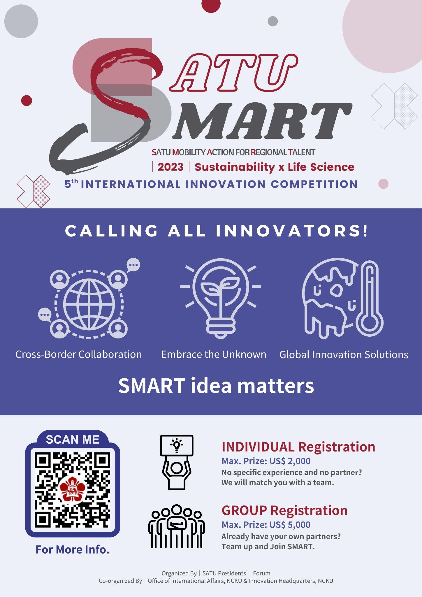

**How to join**

Individual Sign-Up or Group Sign-Up (2-5 members)

Further Details please visit 2023 SATU SMART Website: <https://satu-smart.com/>

**Timeline**

* Sign up period: From today until August 6th, 2023.
* (Individual participation only) Teams created by event staff: August 9th, 2023.
* Pitch deck and video pitch submission: October 5th, 2023.
* Finalist Announcement: October 30th.
* Online Final Presentation (LIVE): November 4th-5th, 2023.
* Announcement of Winners: November 7th, 2023.
* Online Award Ceremony at SATU General Assembly: Mid November, 2023.

**Prizes**

**For Individual Sign Up**

Gold Award: US$2,000

Silver Award: US$1,000

Bronze Award: US$500

**For Group Sign Up**

Gold Award: US$5,000

Silver Award: US$3,000

Bronze Award: US$1,000

**Eligibility**

Participant must be:

a student of a SATU member university (check to see if your university is listed [HERE](https://satu.ncku.edu.tw/p/412-1036-82.php?Lang=en))

**Further Details & Enquiries**

For more details, please visit the 2023 SATU SMART [Linktree](https://linktr.ee/satu.smart) or [Website](https://satu-smart.com/)

Questions? Reach us by email :

✉ [satu.smart.competition@gmail.com](http://satu.smart.competition@gmail.com)

**Organized by**

SATU Presidents’ Forum

Office of International Affairs, National Cheng Kung University

Innovation Headquarters, National Cheng Kung University